**Figure 1: Change in Two-Week Post-Operative Pain from Baseline Pain by SPS Questions**

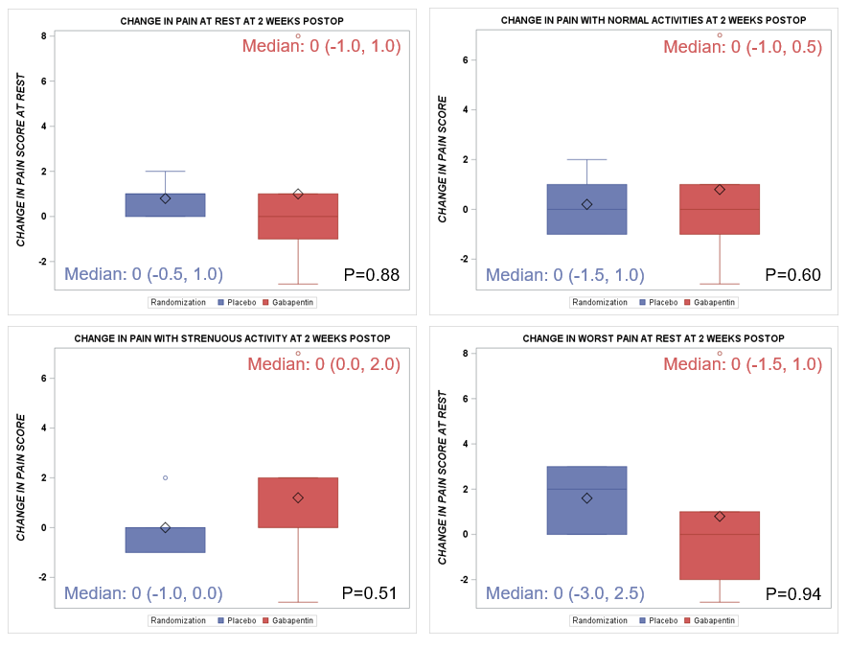

Medians of change in raw two-week pain score from baseline scores based on the Surgical Pain Scale (SPS)

questionnaire are depicted by treatment groups with 25% and 75% quartiles. P-values by Wilcoxon Rank Sum test.