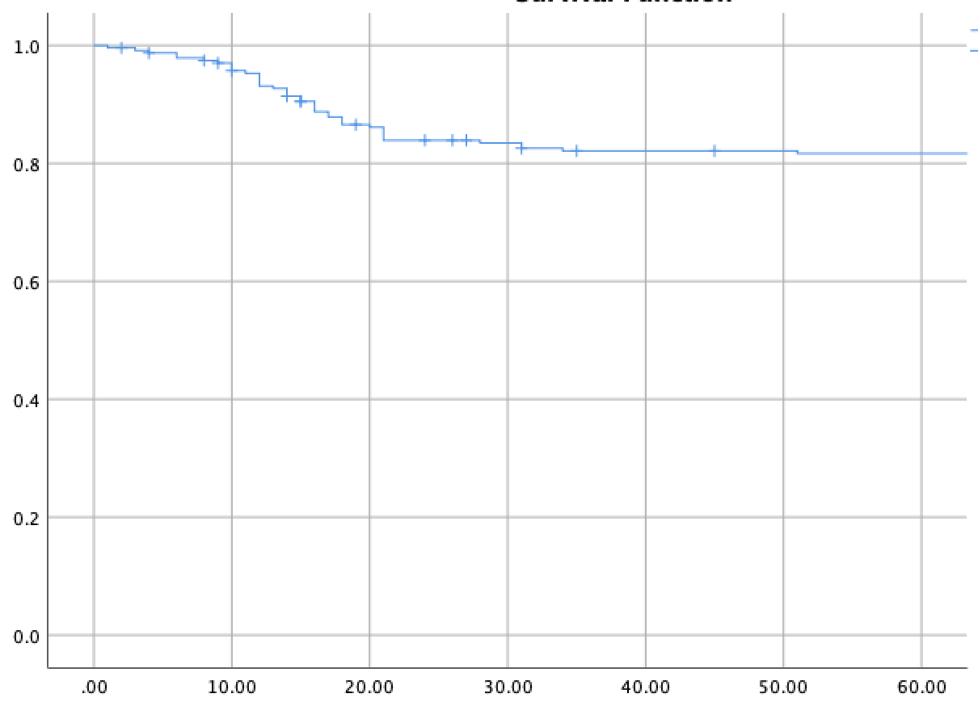

Cumulative Survival

Overall Survival in Months

Figure 2: Overall survival