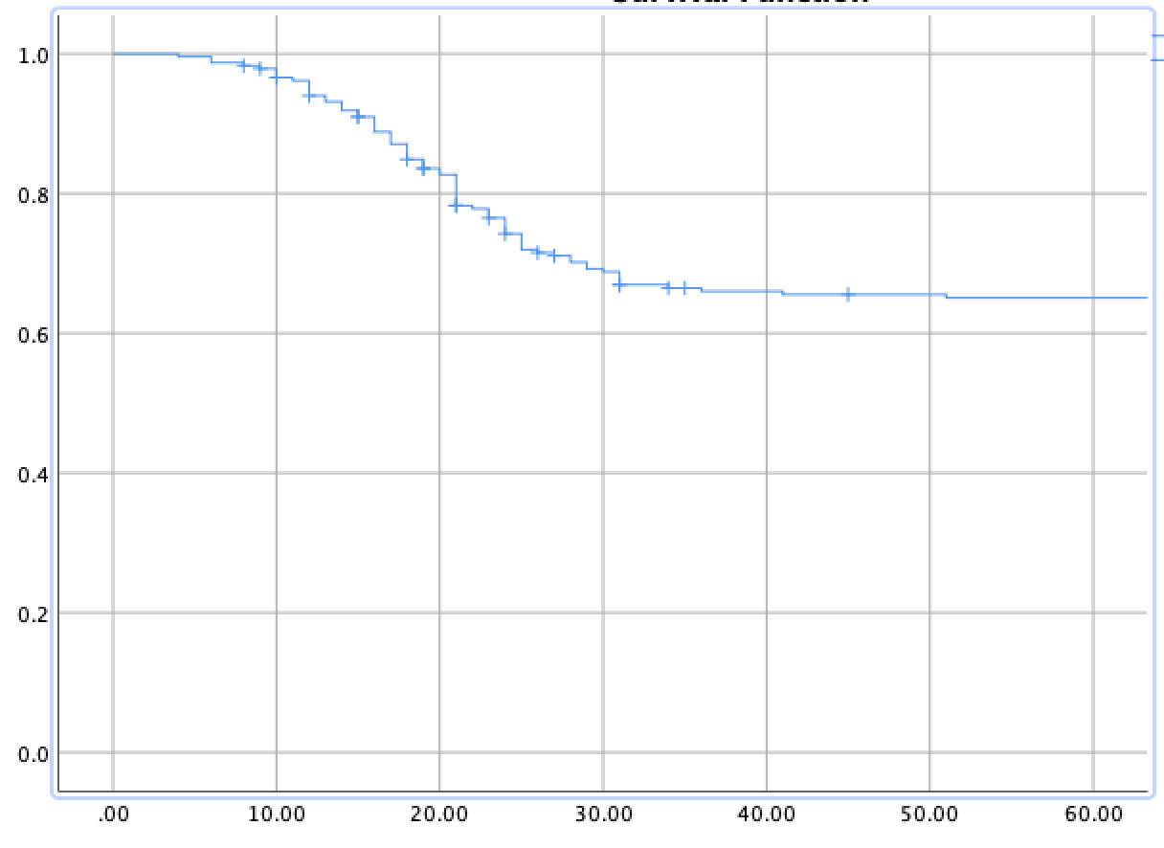
Event-Free Survival in Months
Cumulative Survival

Figure 1: Event-Free Survival

