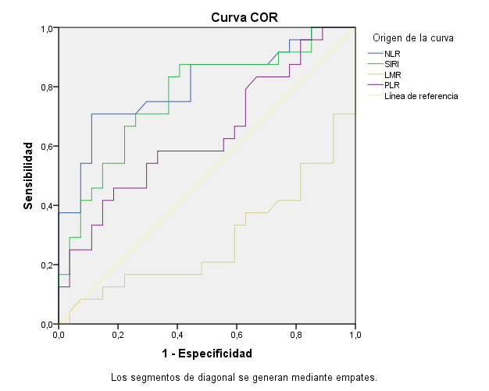

Graph 1: ROC curves for the variables NLR, SIRI, LMR, PLR and survival.

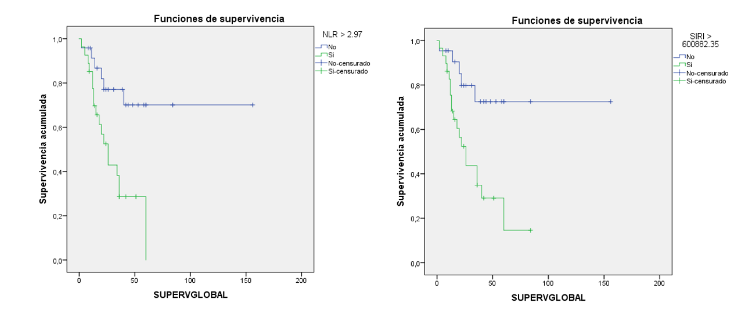
Graph 2: Kaplan-Meier curve based on NLR and SIRI

 | 1 year | 3 years | 5 years
NLR < 2.97 | 91.3% | 77.1% | 70.1%
NLR > 2.97 | 77.4% | 38.2% | 0%
SIRI < 600882.35 | 95.5% | 72.5% | 72.5%
SIRI > 600882.35 | 75.4% | 43.6% | 14.5%

Table 1: Percentage of survival at 1, 3 and 5 years according to the NLR and SIRI cut-off point.

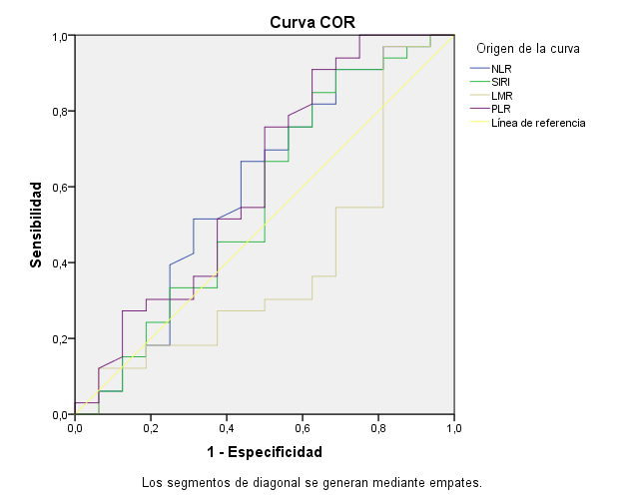

Graph 3: ROC curves, NLR, SIRI, LMR, PLR and recurrence.

