Figure 3. 5-year LRFS, DMFS, OS and DSS according to histology

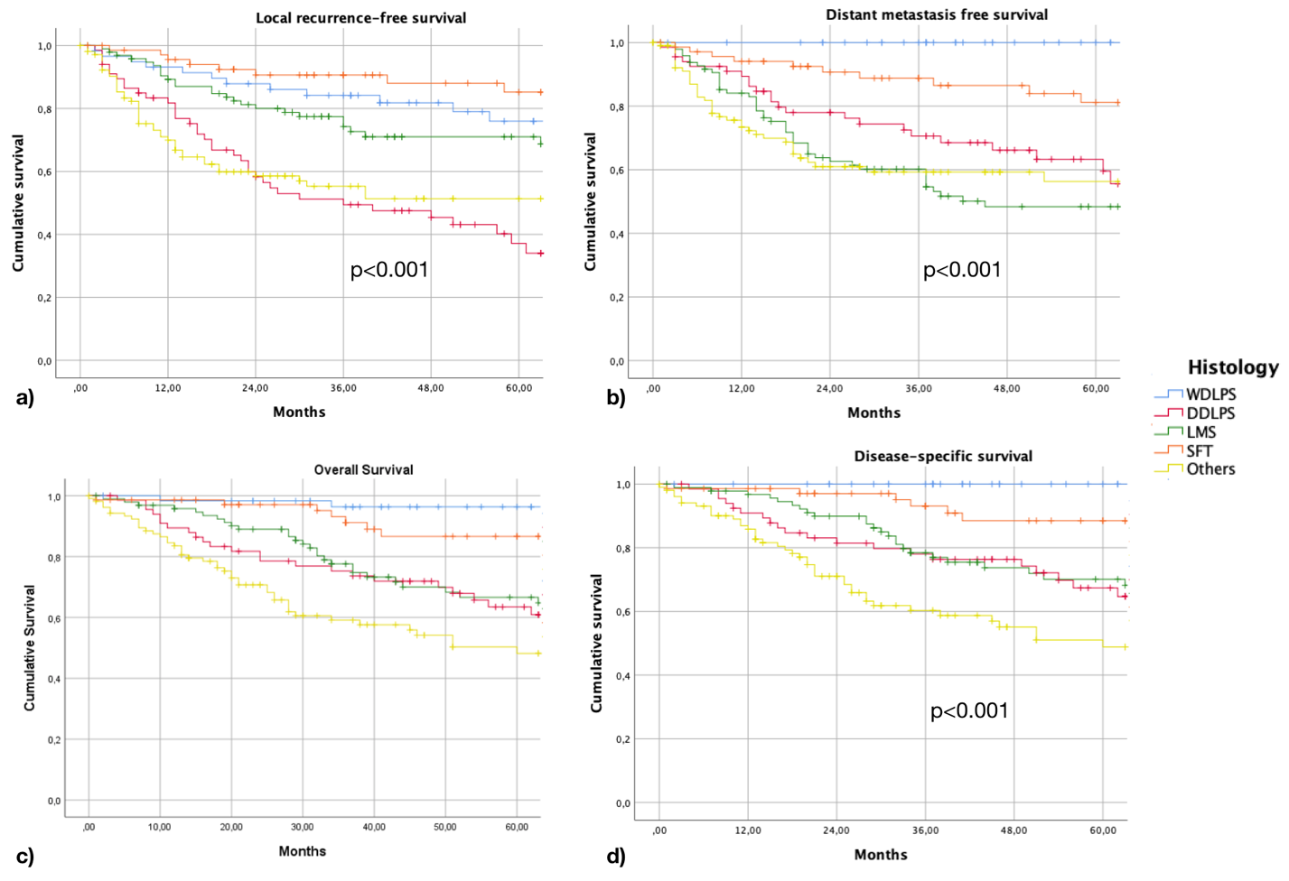

a) Local recurrence free survival, b) Distant metastasis free survival, c) Overall survival and d) Disease-specific survival according to histology

