Figure 2. Organ resection and treatment patterns
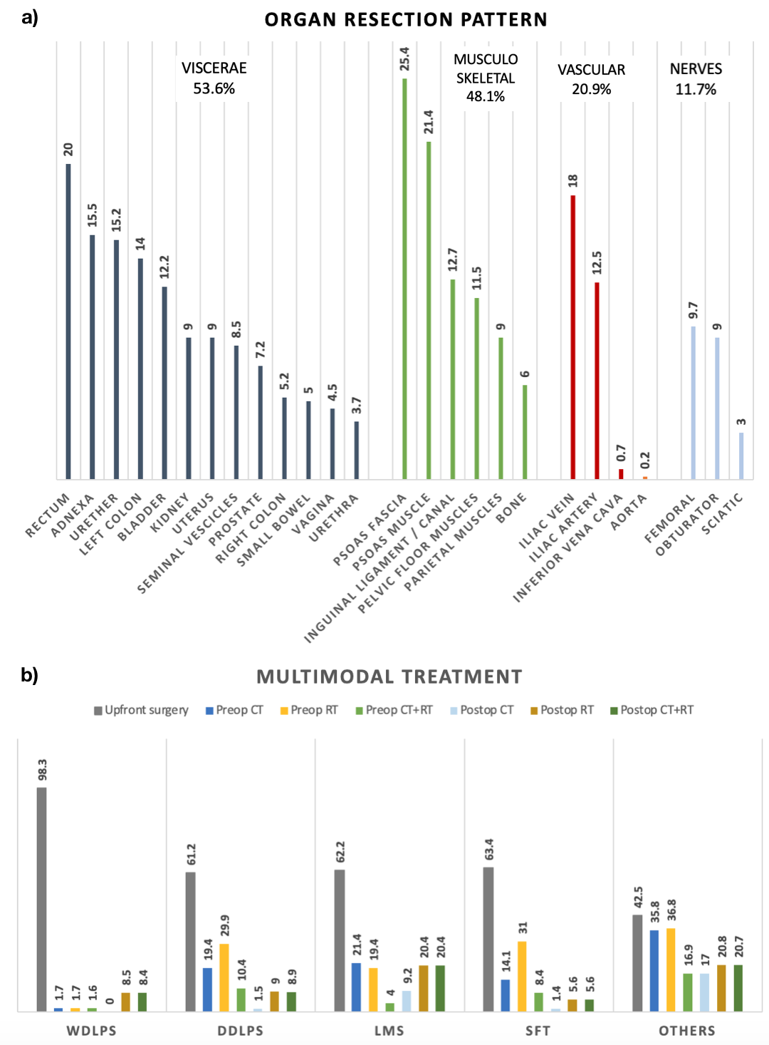
a) Organ resection patterns and b) Multimodal treatment distribution according to histology (%)

