Figure 1. Histology distribution of PSTS compared to RPS series

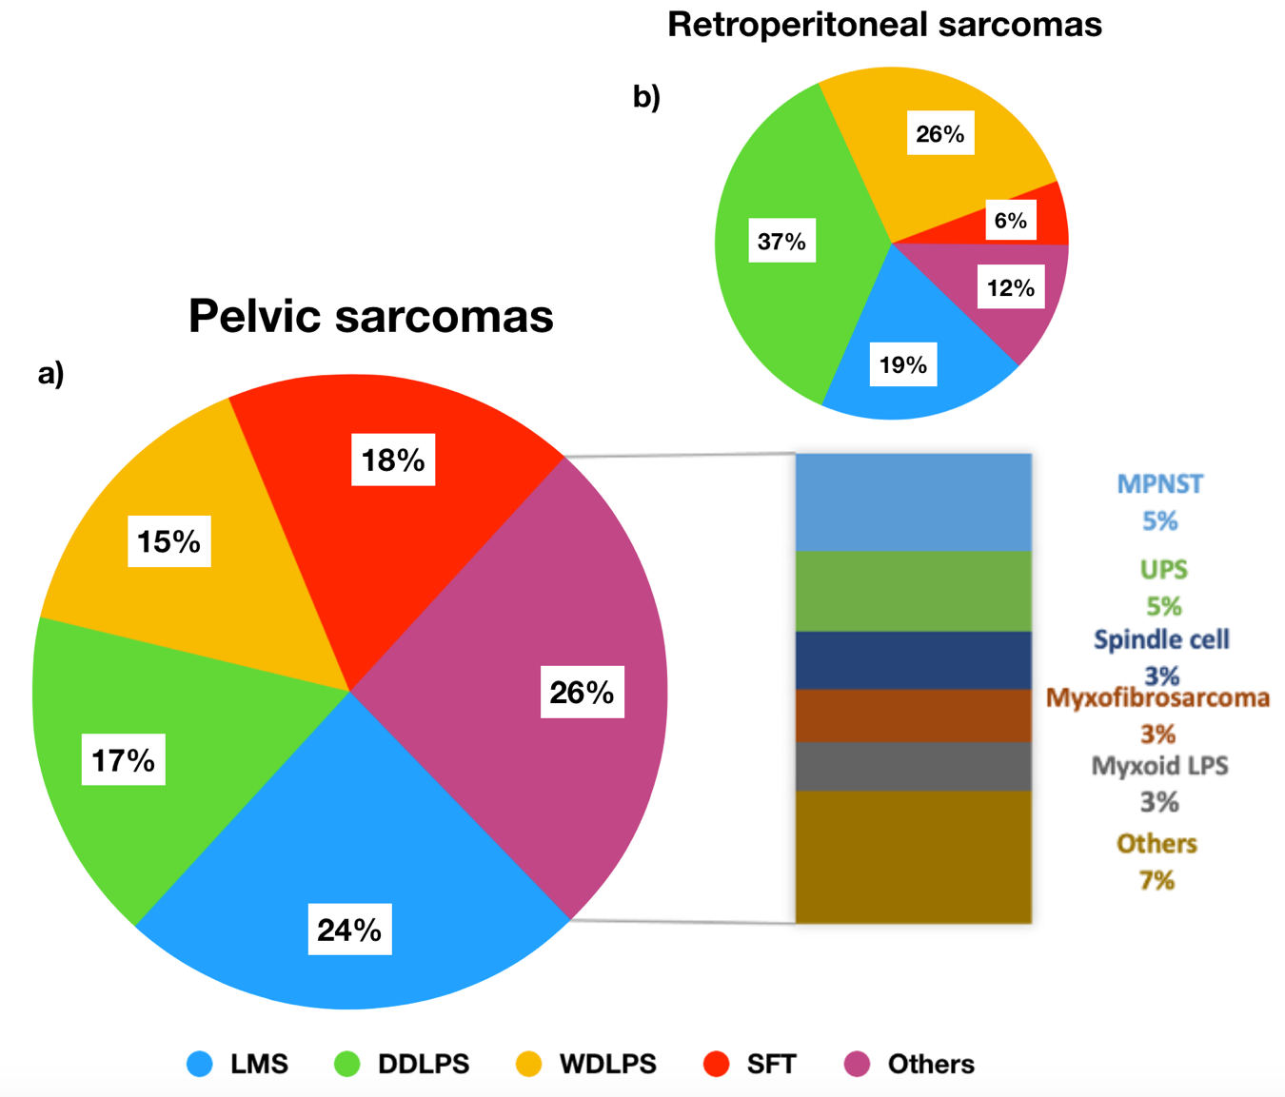
a) Histology distribution of PSTS. b) Histology distribution of RPS. From: TARPSWG, Ann Surg 2016;263(5):1002-1009. DDLPS= dedifferentiated liposarcoma, LMS= leiomyosarcoma, MPNST= malignant peripheral nerve sheath tumor, SFT= solitary fibrous tumor, UPS= undifferentiated pleomorphic sarcoma, WDLPS= well-differentiated liposarcoma.

