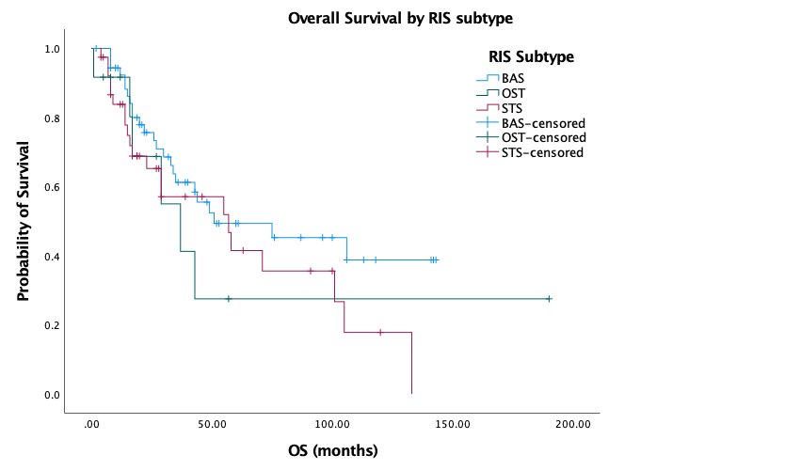

Figure 2: Overall survival by RIS subtype (p=0.32)

