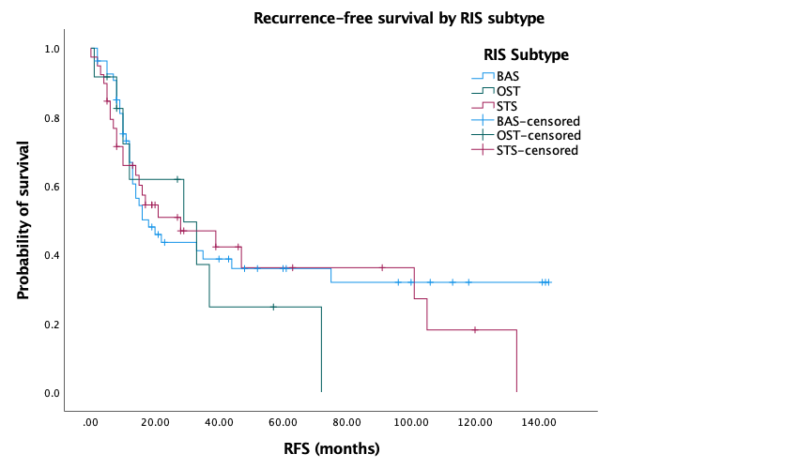

Figure 1: Recurrence-free survival by RIS subtype (p=0.76)

