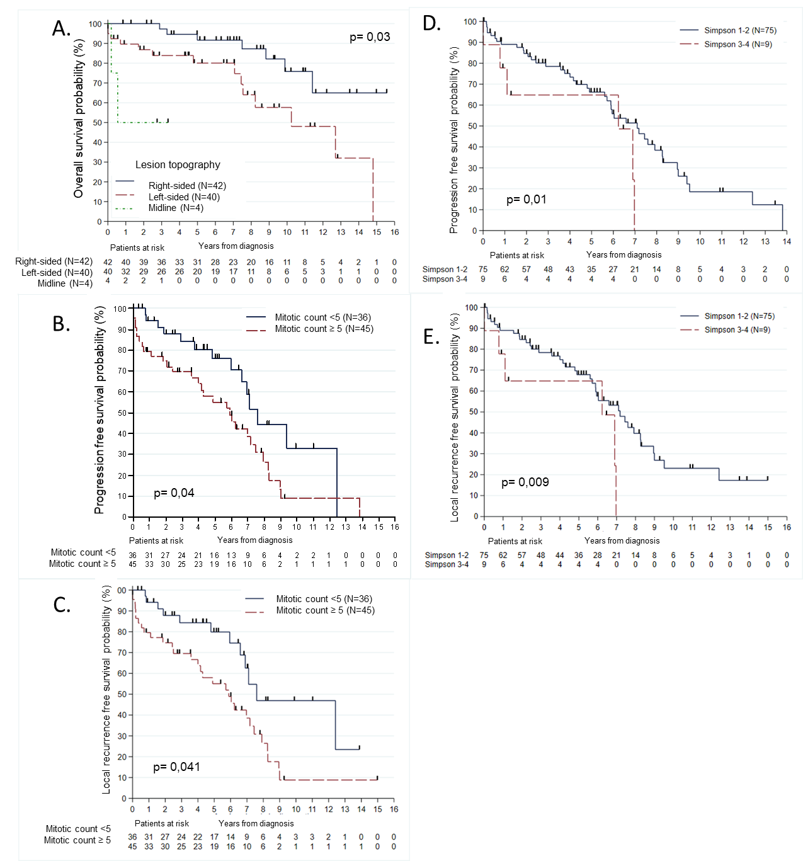
Figure 2: Survival according to morphological, pathological and treatment parameters. Survival curve obtained by Kaplan-Meier method showing the difference of overall survival (OS) according to tumour location (A);progression free survival (PFS) (B) and local recurrence free survival (LRFS) (C) according to mitotic activity and the difference of PFS (D) and LRFS (E) according to the extent of resection with newly diagnosed iSFT/HPC (p value, significant if <0.05).

