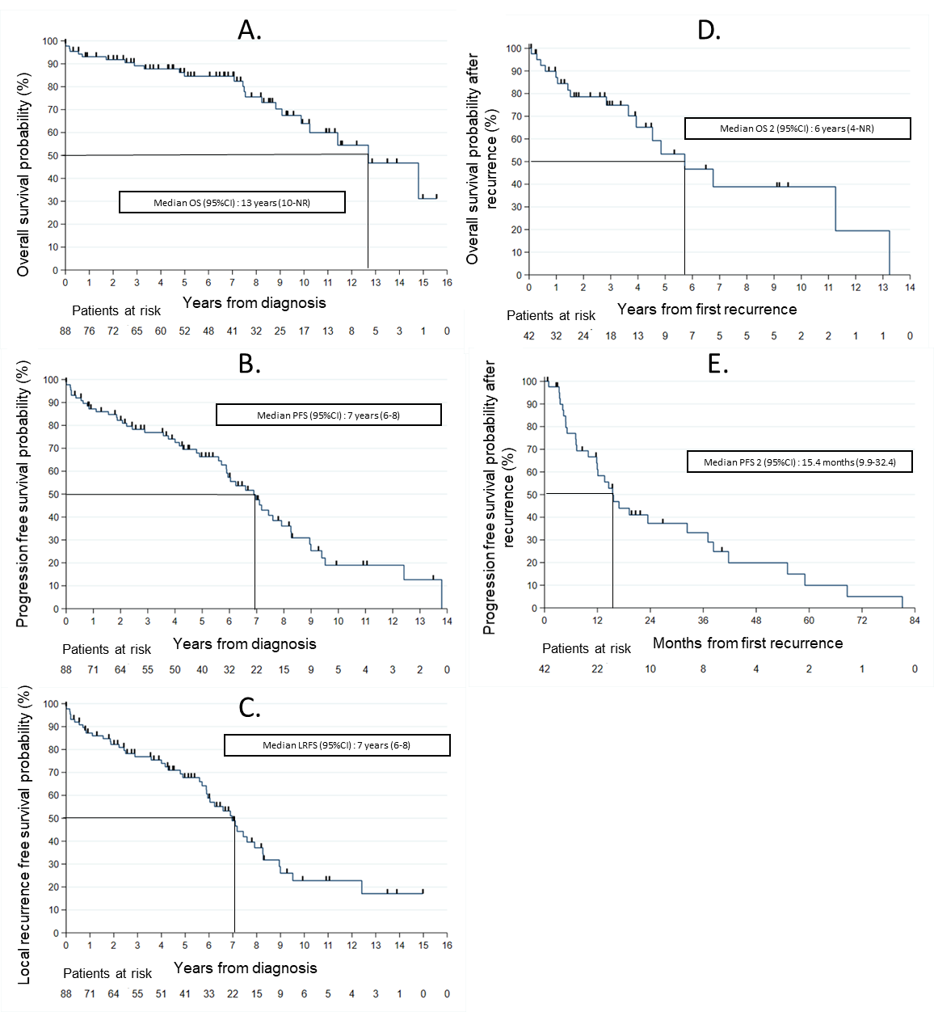
Figure 1: Survival analysis in newly diagnosed and recurrent iSFT/HPC patients. Survival curve according to Kaplan-Meier method showing median overall survival (OS) (A), progression free survival (PFS) (B), local recurrence free survival (LRFS) (C) in newly diagnosed iSFT/HPC and overall survival after the first recurrence (OS2) (D), progression free survival after the first recurrence (PFS2) (E) and their respective 95% confidence interval (95%CI). NR : non reached

