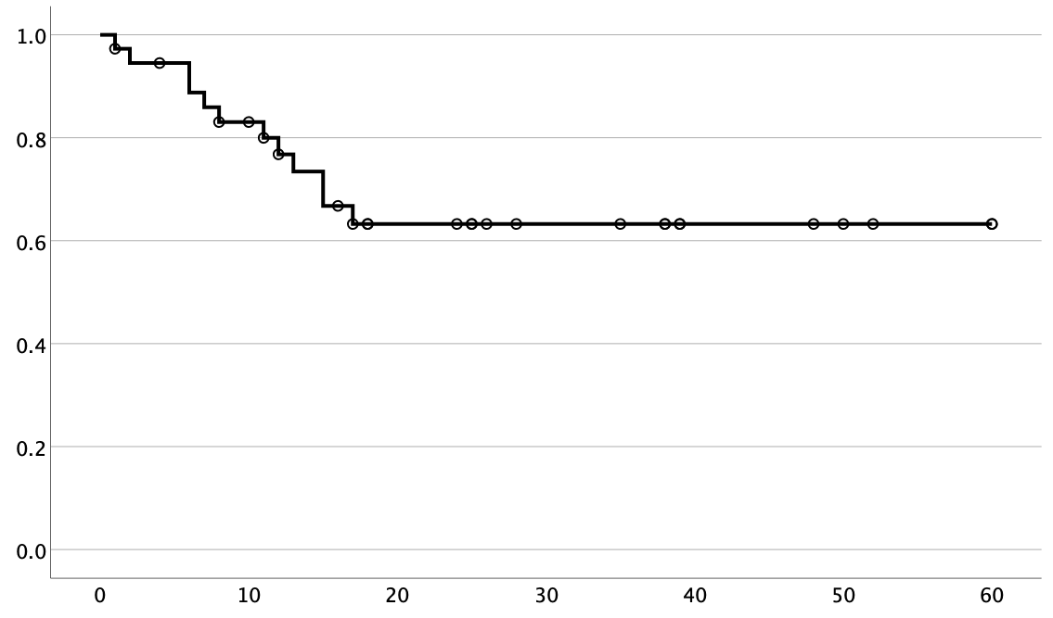

Progression-free survival

**A**

Time (months)

Figure 2 **A)** 5-year progression-free survival of all patients with frontline active surveillance. **B)** 5-year recurrence-free survival for all patients who underwent resection of the DF.

Censored

Recurrence-free survival

**B**

Time (months)

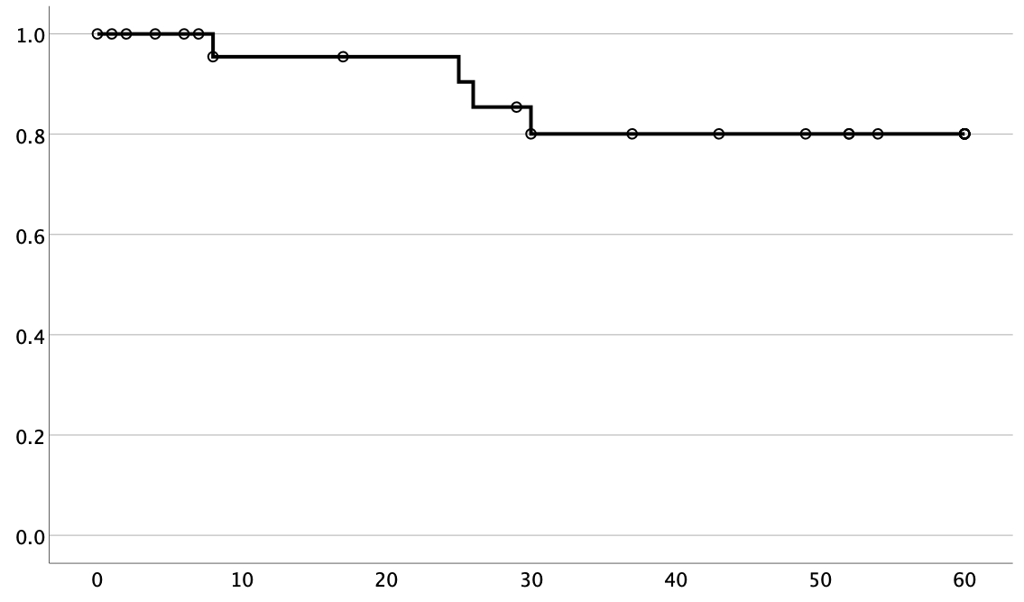

**B**