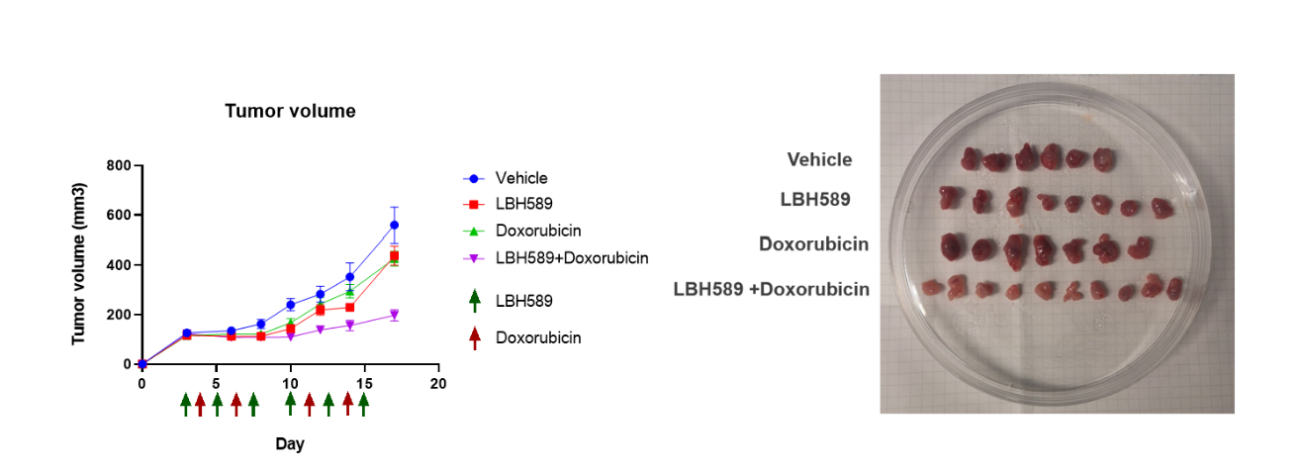

Figure 1. In vivo efﬁcacy of LBH589 + doxorubicin in ES mice models.

