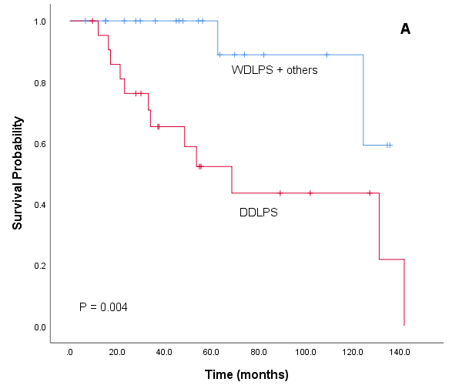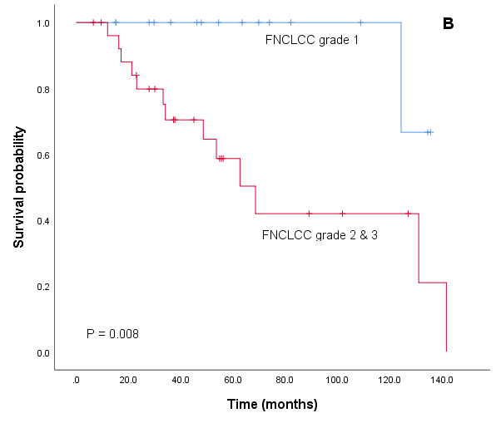
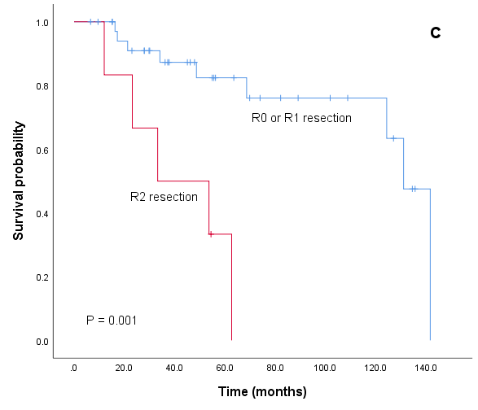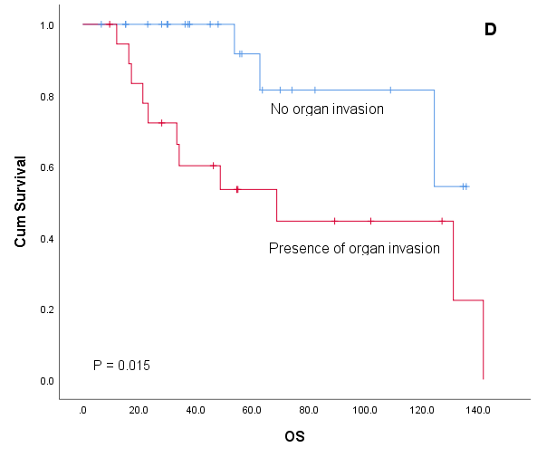
Figure 1
OS in patients with resected retroperitoneal liposarcoma by (A) histological subtype, (B) FNCLCC grade, (C) resection margin, & (D) organ invasion

